Gravity

Introduction
A force is a push or a pull on an object. All objects have a gravitational force, which pulls other objects towards them. The area within which an object’s gravitational force has an effect is known as its ‘gravitational field’. Only massive objects like planets are large enough for us to notice the effect of their gravitational fields. The Earth’s gravitational field is like a friend who is with you all of the time, without you realising – it stops you floating away into space!

Discovering the secrets of gravity
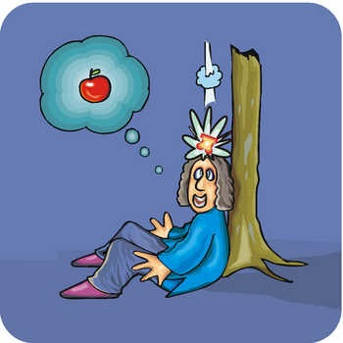
For a long time, people wondered about why things did not float away and why they fell to the ground when we drop them. The Ancient Greeks believed that objects were trying to find their natural place and that the planets were moved by invisible crystal spheres. It was not until the 16th and 17th century that scientists began to understand gravity. Galileo Galilei made some important discoveries about how objects move; for example, that if there was no friction, once an object began to move it would never stop! Isaac Newton then built on Galileo’s work to discover his laws of motion and gravitation. It is said that when Newton saw an apple falling, he wondered if the force acting on the apple could be the same as the one acting on the moon and the planets!

What affects the gravitational force between objects?
The strength of the attraction between two objects depends on the size of the objects and how close they are to each other. The closer two objects are, the greater the strength of the attraction between them. Furthermore the larger an object is, the greater its gravitational pull; in fact we only notice the effect of the gravitational force of massive objects like planets.

What does gravity help to explain?
The planets orbit (move around) the sun because of the sun’s gravitational force. Earth’s gravitational force ensures that objects do not just float off into space, as well as attracting the moon so that it orbits around the Earth. The moon’s gravitational force explains why the oceans have tides. The water in the Earth’s oceans is drawn towards the moon by the moon’s gravitational force.

Mass and Weight
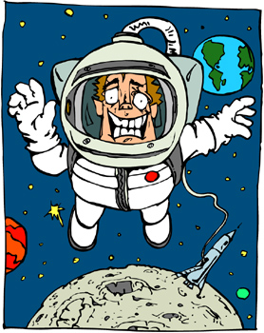
When most people talk about their ‘weight’, what they are really talking about is their ‘mass’. Mass is measured in grams and kilograms and is always the same for an object, no matter where the object is. Mass is a measure of the amount of matter (stuff) that an object contains. Weight is actually a force caused by gravity. Weight is a measure of the pull of gravity on an object’s mass and is measured in Newtons (after Isaac Newton!). An object’s weight will be different in different places. On the moon an object’s weight is only one-sixth of what it is on Earth (because the moon is much smaller than the Earth), whereas on Jupiter an object’s weight would be more than two and a half times as much (because Jupiter is much bigger than the Earth).

What happens without gravity?
The easiest way to see how gravity affects people and objects is to see what happens when gravity is absent. On Earth, people can take ‘zero gravity’ flights, where a plane travels quickly downwards to create a weightless environment. In space, astronauts can be weightless because they are not close enough to the Earth (or any other planet or moon) for the gravitational force of these bodies to have an effect on them.

Conclusion
Gravity is a crucial force for life on Earth and is responsible for the movements of all of the planets, the moon and the tides. It is only in the last several hundred years that scientist have understood how it works. Larger objects have a greater gravitational force and we only notice the effect of the gravitational force of massive objects like stars, planets and moons. The weight of objects changes depending where they are; on larger planets objects have a greater weight, whereas on smaller planets and moons, objects have a lower weight.
You can find planning, with every resource needed to teach it, for teaching ‘Forces’ for the 2014 curriculum at:

References
The Usborne Internet-Linked Library of Science: Energy, Forces and Motion
Eyewitness Science: Forces and Motion
http://www.bbc.co.uk/bitesize/ks3/science/energy_electricity_forces/forces/revision/3/

