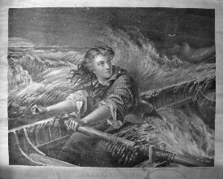

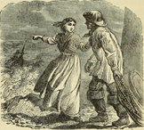

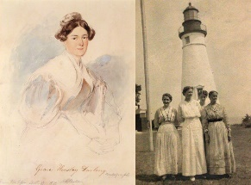

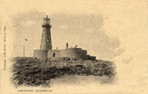

Grace was part of a family of nine children, she didn’t go to school but was taught by her father in the lighthouse, they had no running water and had to row to the neighbouring island to collect the vegetables they grew and look after their animals.

