Geography Task 27.04.20
This week we are looking at landforms in the UK which were formed during the ice age.
Complete the following activity on contour lines.
https://www.ordnancesurvey.co.uk/mapzone/map-skills/relief-and-contours
You can also revise ordnance survey symbols on this site.
Look at the contour lines on this map of Buttermere in the Lake District.
1. What do the contour lines tell you about this area?
2. What geographical features can you see on the map?
3. Can you see any man made features on the map?

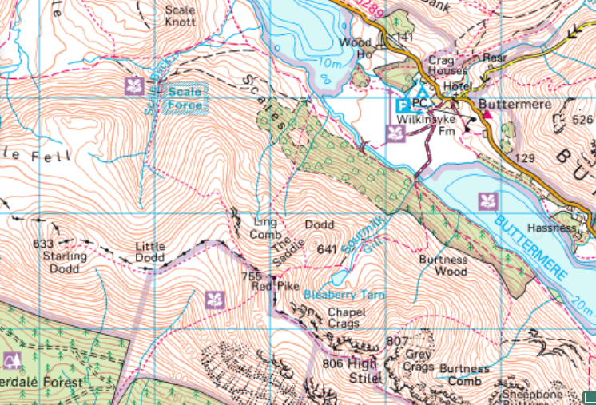
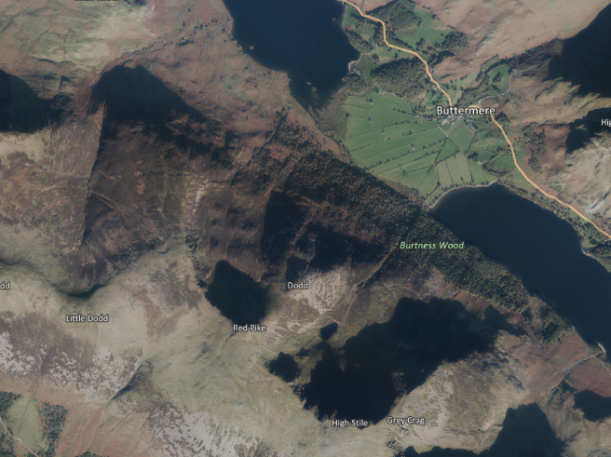
Can you match the features on the map to the features on the aerial photograph?

