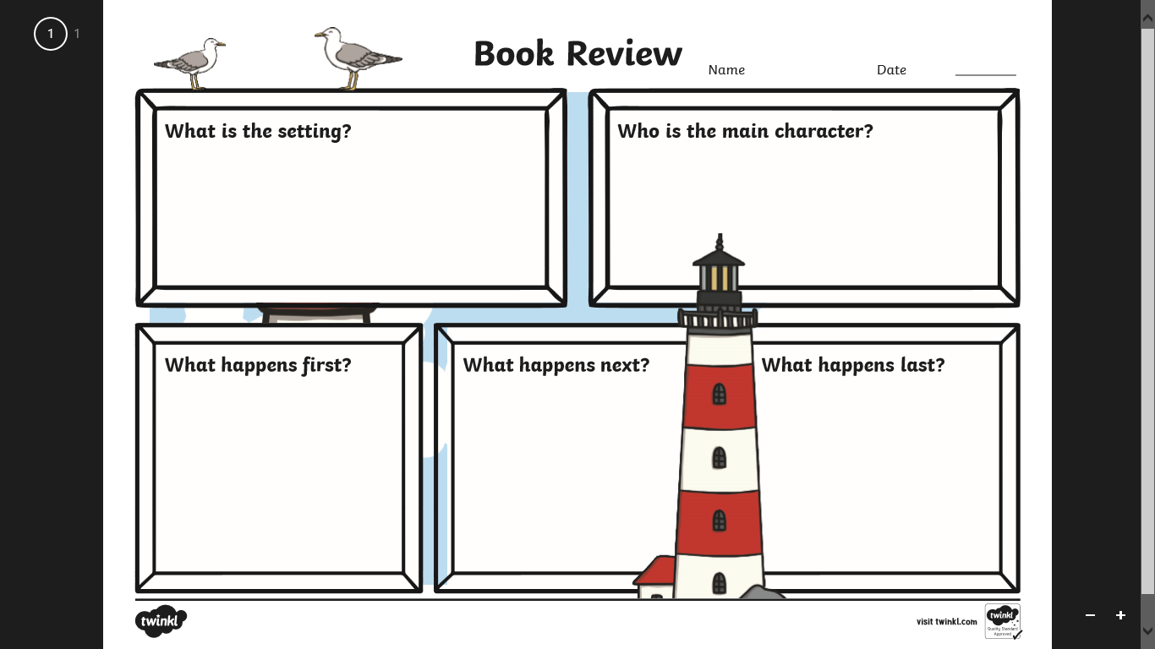

**Monday Task**

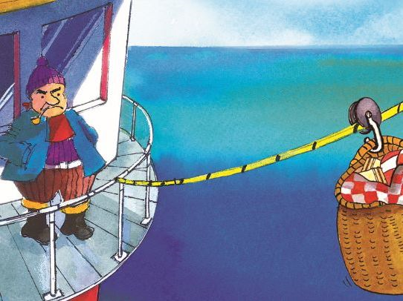

Mr **Grinling** is a lighthouse keeper. Listen to the story

carefully and write some sentences about his role.

____________________________________________________________________________________________________________________________________________________________________________________________________________________________________________________________________________________________________________________________________________________________________________________________________________________________________________________________________________________________________________________________________________________________________________________________________________________________________________________________________________________________________________________________________________________________________________________________________________________________________________________________________________________________________________________________________________________________________________________________________________________________________________________________________________________________________________________

_________________________________________________________________________________________________________________________

_________________________________________________________________________________________________________________________

**Tuesday Task**

**Wednesday Task**

Complete the challenge set my Marcel the lighthouse keeper. Design, label and write **descriptive** sentences about your lighthouse design.

______________________________________________________________________________________________________________________________________________________________________________________________________________________________________________________________________________________________________________________________________________________________________________________________________________________________________________________________________________________

_________________________________________________________________________________________________________________________

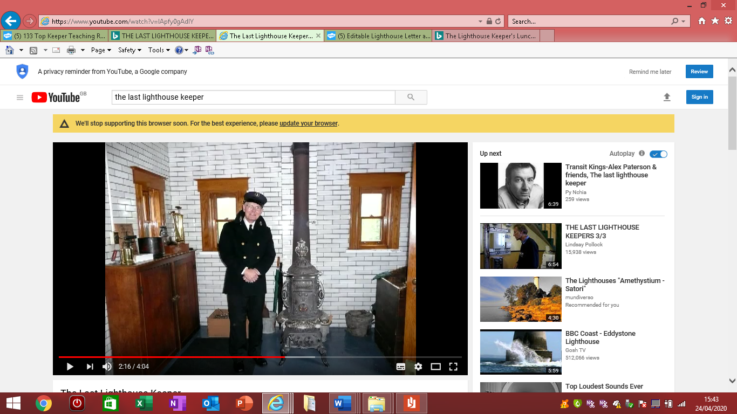

________________________________________________________________________________________________________________________________________________________________________________________________________________________________________________________________________________________________________________________________________________________________________________________________________________________________________________________________________________________________________________________________________________________________________________________________________________________________________________________________________________________________________________________________________________________________________________________________________________________________________________________________________________________________________________________________

______________________________________________________________________________________________________________________________________________________________________________________________________________________________________________________________________________________________________________________________________________________________________________________________________________________________________________________________________________________________________________________________________________________________________________________________________________________________________________________________________________________________________________

_________________________________________________________________________________________________________________________

_________________________________________________________________________________________________________________________

**Thursday Task**

The Last Lighthouse Keepers

Write about how the lighthouse keepers felt.

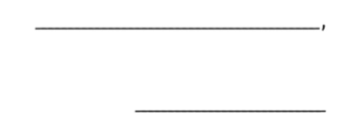

**Friday Task**

Write a letter to one of the lighthouse keepers.