**Geography Home Learning Task Week 20.4.20**

Our new geography topic is **“What shaped our world?”**

You could watch some of “The Birth of Britain” on YouTube to give you some ideas, especially the Ice Age episode.

Look at the places below. How do you think they were formed?

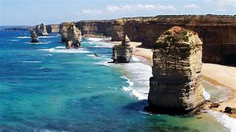

The Twelve Apostles

**Key Vocabulary**

ICE TECTONIC WEATHER RIVER WAVES

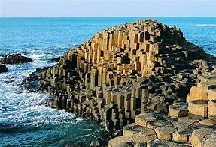

The Giant’s Causeway

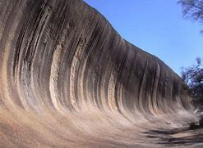

Wave Rock