Day | Weekly spellings | Daily English Task  Weekly Focus: writing a story. | Daily Maths Task  Weekly Focus: Time  (5x tables, focus on confident and quick recall throughout the week). | Other Subjects
Monday | - Limiting  - Limited  - Limitation  - Young  - Touch  - Double  - Trouble  - Country  - Disappoint  - Disagree  - Disobey  - Misbehave  - Mislead  - Misspell  - inactive | Explain that this week they are going to be working towards writing a story. If possible, look at an example. Discuss the features of a story. Write a success criteria for what to include as a list to refer back to throughout the week.  Recap what a noun is. Read the passage, whenever they read a noun they have to jump:  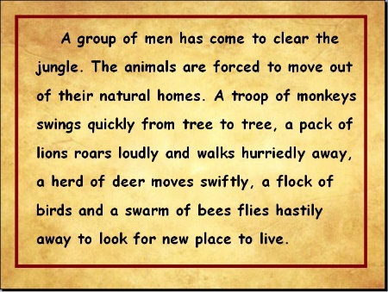 | Recap what the children have already learnt whilst learning time. Discuss/look at counting around the clock in 5 minute intervals. Use this video to support understanding: https://www.google.com/search?source=hp&ei=wn18XuvlHMOUkgXbmZ7YAQ&q=telling+the+time+to+the+nearest+5+minutes&oq=telling+the+time+to+&gs_l=psy-ab.3.0.0l10.5054.7412..8865...0.0..0.105.1566.19j2......0....1..gws-wiz.....6..0i362i308i154i357j0i131.cgm-766XEME#kpvalbx=_zH18XoKTBoy0gAan7ZOYAQ52  Use the TopMarks online clock to develop fluency understanding. https://www.topmarks.co.uk/time/teaching-clock Then, work through the two sheets, the first one you need to read the clock and write the time it is displaying, the second sheet you need to draw the hands on the clock to match the time it has wrote. | Science- Recap what the children learnt previously (pushes and pulls). Begin to introduce vocabulary such as friction and gravity when pushing and pulling. Complete push and pull worksheet. Look at the videos on BBC https://www.bbc.co.uk/bitesize/topics/zf66fg8 to support understanding.
Tuesday |  | Recap what a noun is, give 3 examples of a noun. Today, they need to expand the nouns using adjectives. Give examples of adjectives.  Task 1 (see other sheet) underline the expanded noun phrases in each sentence. Then, write 6 sentences using expanded noun phrases. | Recognising time to the nearest minute. Recap how many seconds are in one minute, how many minutes are in an hour. Discuss how you can tell the time to the nearest minute. Again, use https://www.topmarks.co.uk/time/teaching-clock to support fluency understanding. Work through the sheet (see other sheets). | Geography – Recap their previous work on arguments for and against visiting a city. Write a balanced argument about visiting a city. Try to use the language practised during English lessons.
Wednesday |  | Similes – recap using these to continue developing understanding. Explain how these up level stories by using them throughout. (A simile is when you use like or as to describe something, for example, the sun is as hot as fire). Complete these 6 sentences:  - The tower is as tall as…  - It was as white as…  - It is as hot as…  - She is fast like…  - He is wise like …  - It is as small as… | Discuss start and end times and how you could possibly work out how long something is on for.  Look at an example of using a number line to see the end time of something, based on its start time and the length of time something is on for.  Look at the film start times (see other sheet) and workout what the time film will finish based on the time it lasts. See other sheet. | Art or DT  Create the illustrations for their story (English). | RE (Optional) – Research to find out about how people celebrate Easter, including Easter traditions.
Thursday |  | Recap using inverted commas for direct speech. Listen to the inverted comma song https://www.youtube.com/watch?v=uoE9ET6CtaI  Write 6 sentences using inverted commas, base this on what Mr and Mrs Dearly would say when they discovered the missing Dalmatians.  Plan to write a story about Cruella De Vil stealing the Dalmatians. Plan a plot twist and Cruella turns out to be the hero and Mr and Mrs Dearly are the villans. Look back at the criteria list from Monday to recap what to include in the story. | Recap using number lines to work out the length of time. Use this train timetable to answer the questions (see other sheet for an enlarged version, including the questions). 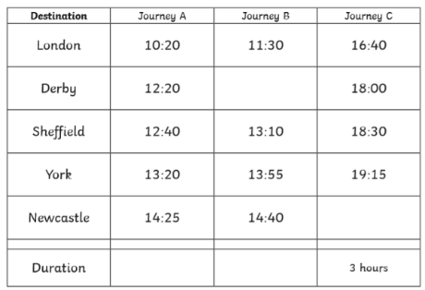 | Computing –  Watch the SmartCrew episode https://www.childnet.com/resources/the-adventures-of-kara-winston-and-the-smart-crew/chapter3 create an example of a good digital profile and an example of a bad digital profile. | MFL – Recap Spanish greetings. Watch https://www.youtube.com/watch?v=rgks_-AWj74 and create a comic strip of two characters having a conversation using these Spanish phrases.
Friday |  | Spelling test. Record a score out of 15.  Recap their plan for writing their story. Explain that today they are going to write the story with a plot twist. Recap the list made on Monday of what to include. Upon completion, create the illustrations to match the story (see art). | Recap what am and pm mean. Discuss using a 24 hour clock. Use TopMarks to support understanding of adding 12 hours to the time to turn it into the 24 hour or subtracting 12 hours to turn it from 24 hour to 12 hour. https://www.topmarks.co.uk/time/teaching-clock  Complete the sheet (see other sheets). | PE/ Movement – Joe Wicks 9:00am every morning, PE sessions. YouTube.
Useful websites:
https://ttrockstars.com/
Build up their score to create their rock star by practising times tables. Login is in their homework book.

www.topmarks.co.uk
Hit the button times table challenge game and others.

uk.mathletics.com- Your child’s login is in their homework book.

Extra reading books
https://www.oxfordowl.co.uk/

Games and clips
https://www.bbc.com/bitesize/subjects/zv48q6f

www.phonicsplay.co.uk

https://www.myon.co.uk/
Linked to accelerated reader, read books based on their individualised ZPD.

If you need any password/usernames contact me via dojo and I will make sure I have these with me.

