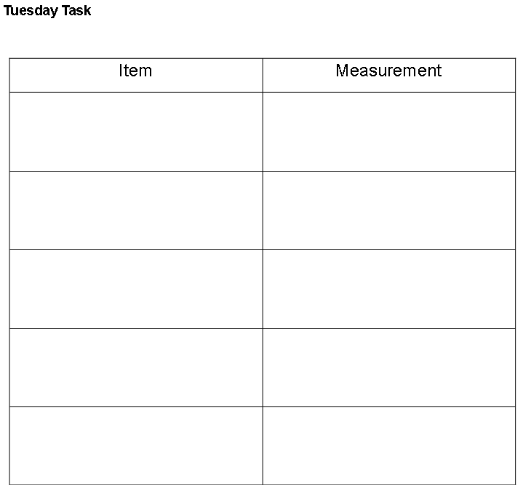

**Wednesday Task**



**1**



**2**



**3**



**4**

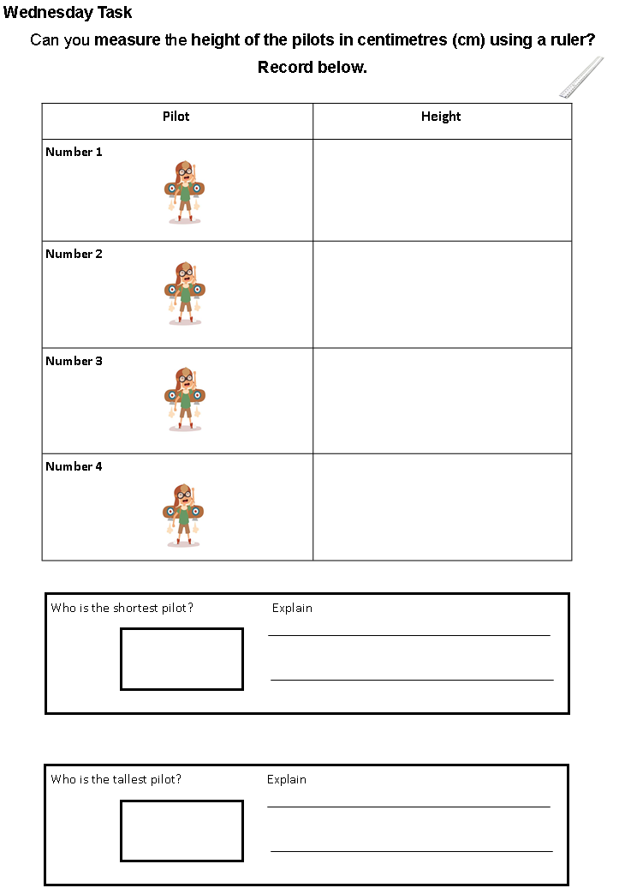

**Thursday Task**

**Which flower is the tallest?**

**How many cm tall is the shortest flower?**

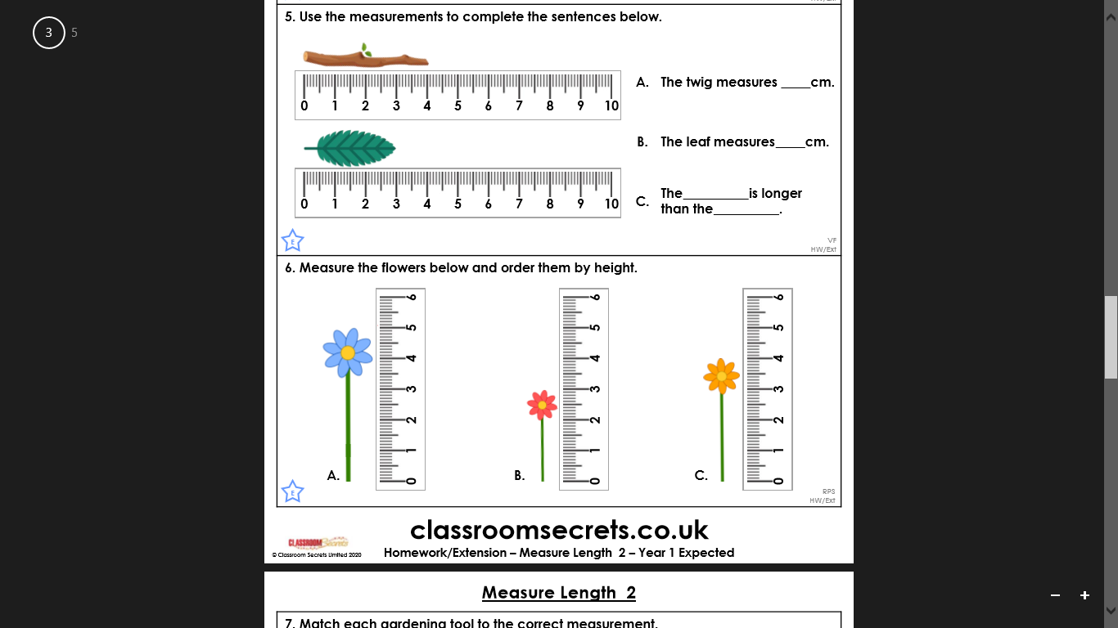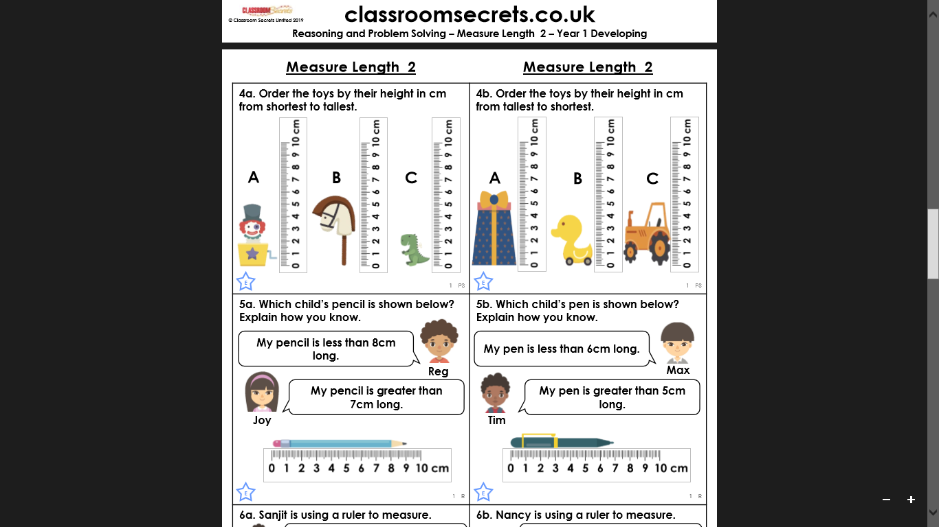

**Which is the tallest toy?**

**Which is the shortest toy?**

**A**

**B**

**C**

**A**

**B**

**C**

**Friday Task 1**

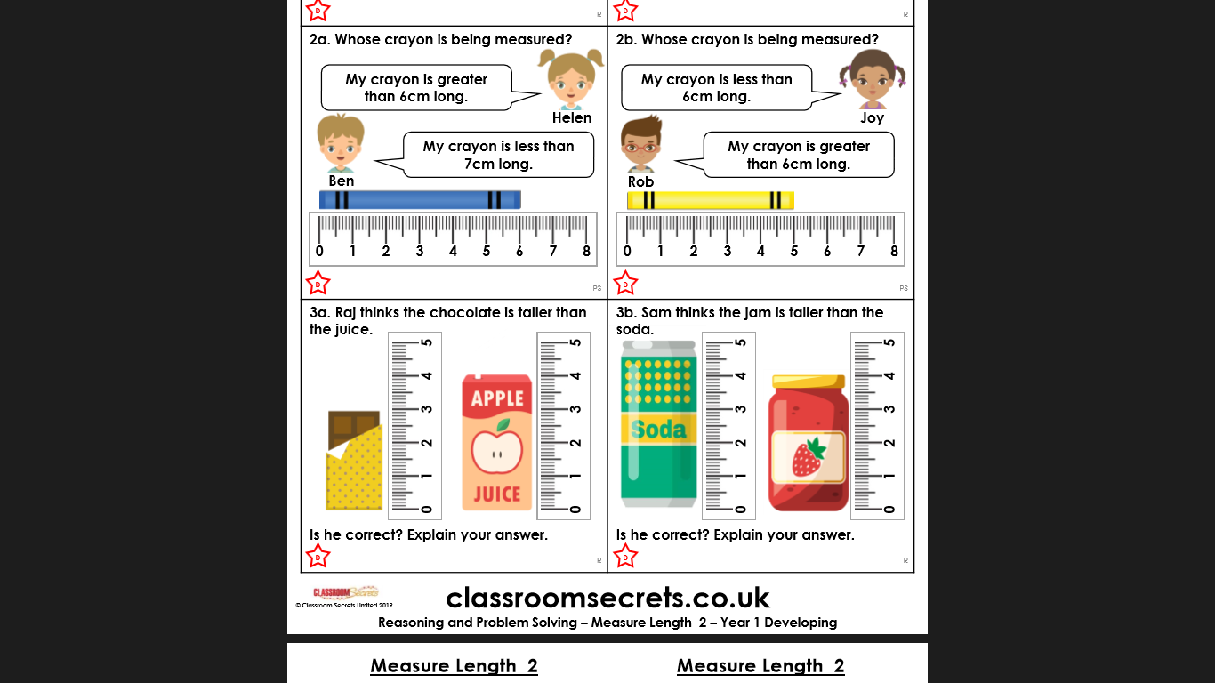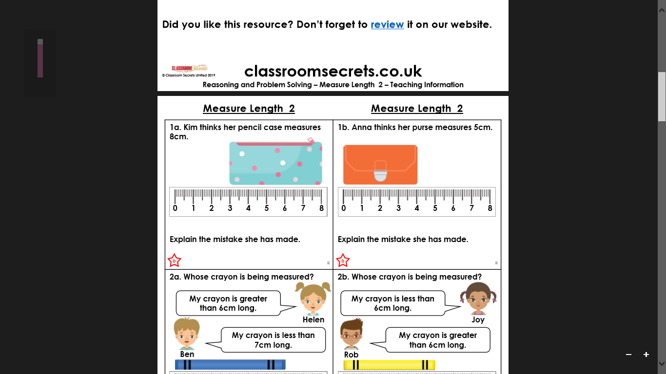

**Friday Task 2**

