English/Phonics Tasks | Maths Tasks | Other Things that you could do
Listen to the story ‘The Snail and The Whale’ written by one of our favourite authors, Julia Donaldson.  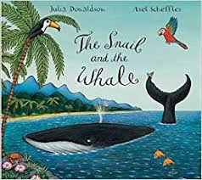  Before listening to the story, do they recognise the animal on the front? Talk about the animals on the front of the book. What do they think might happen in this story? Read the story if you have it at home or watch it online on the below link.  Ask children questions along the way to check their listening and understanding.  Questioning ideas:  Should he have gone with the whale?  What would the other snails have said to him would you go if you were him?  What could the snail do to help the whale?  Why was he so determined to help?  What would you do if you were the snail?  How might the snail have felt when the sea was rough.  What did you like?  What did you dislike?  Youtube link  The Snail and the Whale | Julia Donaldson | Axel Scheffler | children's book | Story time  https://www.youtube.com/watch?v=hheolVGZVvs  After reading the story book, watch the online animated version of the story by the BBC.  Watch ‘The Snail and The Whale’ on BBC iplayer.  https://www.bbc.co.uk/iplayer/episode/m000cslw/the-snail-and-the-whale  See if your child can join in with the phrases throughout the story.  Compare the book and the animation.  Do they notice anything different in the animation that was not in the book? | Ask your grown up write numbers 0-10 across some paper.Count along the number line.  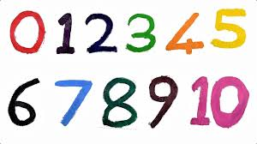  Pick a number from the number line.  See if you can group together objects to make this number. How many numbers can you make by grouping objects?  You could use buttons, sticks, spoons, sequins toys etc.  Remember to count out the objects as you place them.  When playing with building bricks or small toys, encourage your child to count how many of each colour or size.  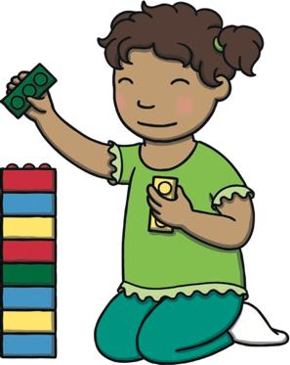  Watch Number blocks ‘How to count’ on iplayer.  https://www.bbc.co.uk/iplayer/episode/b08cr24d/numberblocks-series-1-how-to-count  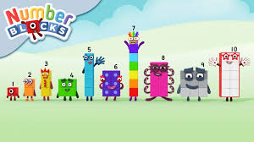  Watch the ‘Our favourite number songs’ video on Youtube on the Super Simple Songs channel. Sing along and remember to hold up the correct fingers when counting.  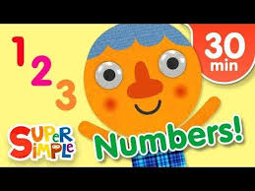  Encourage your child to help you when out shopping by counting and collecting objects  to put into the basket, e.g. ‘Can you get 2 apples?’  Remember to send pictures on the class dojo! | Make some paper snails by decorating and curling up paper.  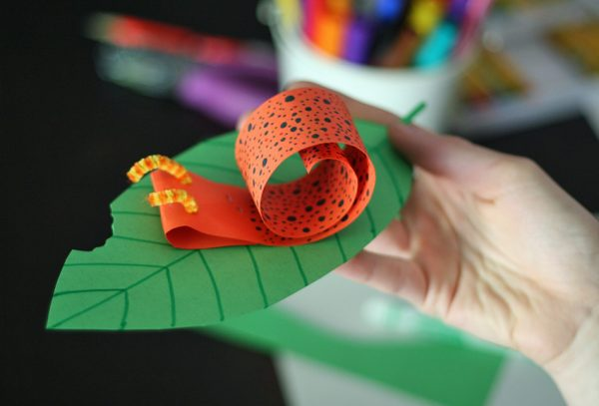  Listen to the snail facts on the uploaded snail fact card file.  Watch some snail videos on Youtube.  Go hunting for snails in the garden. Look under wood and in damp places.  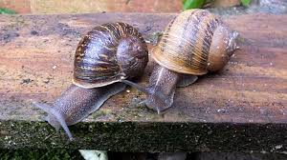  Watch some whale videos on Youtube and find out some whale facts.  Pick your favourite whale and make a whale picture.  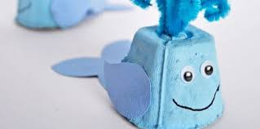  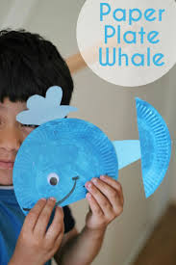  Spring  Go for a walk with a grown up and look for signs of spring.  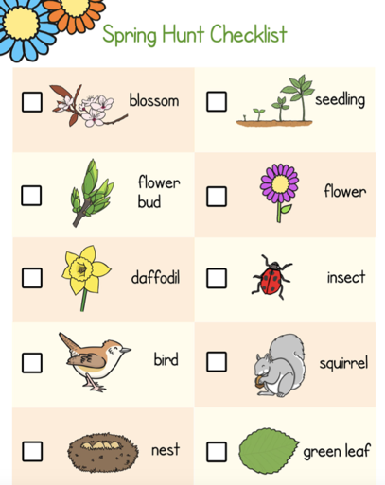  Draw a picture to show what you saw.  During spring seeds begin to grow. Plant some seeds outside or in a small pot to observe during spring time.
Practise your pencil control.

Copy over some shapes using a pen or pencil Try your best to hold your pencil correctly and stay on the line.
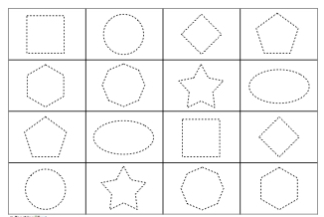

Use some scissors and attempt to cut out the shapes.

Watch the jolly phonics phase 2 song on Youtube.
Join in with the words and actions.
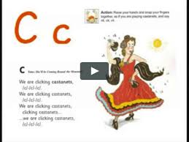

Can a grown up write your name and then separate the letters.
See if you can put them back together in the write order

Practise writing your name in lots of different colours . If you find this tricky, ask your grown up to write it down for you to copy or trace over.
If you want, send it on Class Dojo to show me!

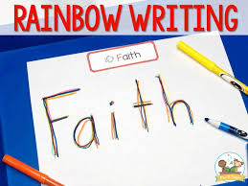

Recap the letters and sounds for ‘a’ and ‘t’.

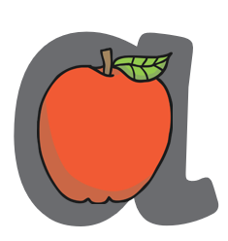
Bounce: a-a-a-apple
Handwriting: Round the apple, down the leaf.
Practise forming the letter ‘s’. Remember to start and finish in the correct place. Say ‘ “Round the apple down the leaf” as you form your letters.

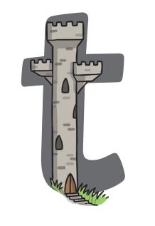
Bounce: t-t-t-tower
Handwrite: Down the tower, across the tower.
How many things around the house can you find begging with the ‘t’ sound.

Practise forming the letter ‘t’. Remember to start and finish in the correct place. Say ‘ Down the tower across the tower” as you form the letter.
Send some pictures of your phonics work on the class dojo to show me!

