English/Phonics Tasks | Maths Tasks | Other Things that you could do
Watch ‘Commotion In The Ocean’ by Giles Andreae on YouTube (page -Mr Bakers Bookshelf).  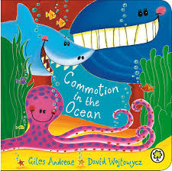  After you have watched the video, how many sea creatures can you remember from the story?  Ask your grown up to help you watch some videos about some of the sea creatures that you enjoyed from the book.  Pick a favourite sea creature from the book and see if you can draw the sea creature. Describe it to your grown up. | Top marks website – Counting sea creatures.  Count the different creatures and find the correct number to show how many there are.  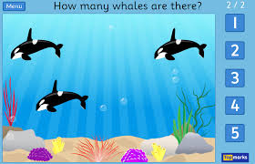  Watch the ‘Our favourite number songs’ video on Youtube on the Super Simple Songs channel. Sing along and remember to hold up the correct fingers when counting.  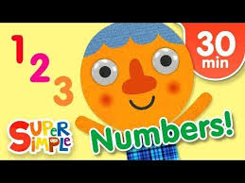  Ask your gown up to draw a row of fish. Chose two colours for the fish and make a repeating pattern ‘under the sea’ picture. You could even use paint to complete the picture.  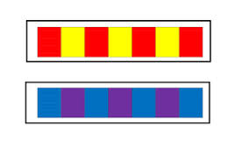  Remember to send pictures on the class dojo! | Play an under the sea movement game. Children do a different movement for each sea creature that is called out.  Starfish – lay on the ground with arms and legs outstretched.  Octopus – spin around slowly wiggling arms or get into a group of 4 and stand back-to-back with arms outstretched.  Fish – run around the space using wiggly movements with hands in front of them like the pointy nose of a fish.  Crab – walk sideways with arms at sides and making snapping movements with hands.  Shark – run around the space (avoiding obstacles!) making large snapping movements with arms.  Jellyfish – walk slowly around the hall with wobbly movements!  Whale – move slowly around the space, walking in and out of the spaces.  Complete the Joe Wicks live PE session online at 9am  Provide materials for your child to create their own rock pool. This could include clear plastic trays or bowls, water, sand, pebbles, green/brown cellophane, shells and plastic sea creatures. Encourage your child to investigate the changes in the clarity of the water as the sand settles, how the cellophane feels when it is wet etc.  Take some pictures.
Practise your pencil control.
Copy over some wavy and zig zag lines using a pen or pencil Try your best to hold your pencil correctly and stay on the line.

Watch the jolly phonics phase 2 song on Youtube.
Join in with the words and actions.
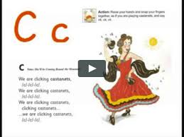

Practise writing your name. If you find this tricky, ask your grown up to write it down for you to copy or trace over.
If you want, send it on Class Dojo to show me!
Recap the letter ‘s’.
‘Ssssssssnake’.
How many things around the house can you find begging with the ‘s’ sound.

Practise forming the letter ‘s’. Remember to start and finish in the correct place. Say ‘ Slither down the snake’ as you form the letter.
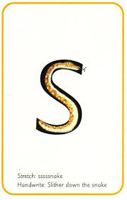
Send some pictures of your phonics work on the class dojo to show me!

