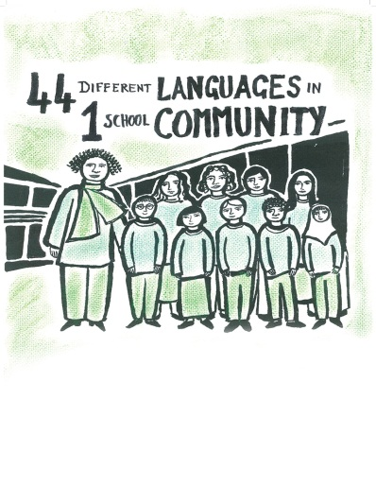

The Anglo Saxons and The Mayans
Comparison sort cards
Subject: | History
Age groups: | 8-11
Topic: | A Non-European society that provides contrasts with British history

This project and its actions were made possible due to co-financing by the European Fund for the Integration of Third-Country Nationals.

This project and its actions were made possible due to co-financing by the European Fund for the Integration of Third-Country Nationals.

This project and its actions were made possible due to co-financing by the European Fund for the Integration of Third-Country Nationals.

The Mayans in Mexico | The Anglo Saxons in England
They used astronomy to develop a calendar.
They developed a complex number system.
There were no significant advances in mathematics.
There were no significant advances in astronomy.
They made animal sacrifices to their gods.
They made human sacrifices to their gods.
Schools were for nobles to learn to read and write.
They used hieroglyphs for writing.
They used runes for writing.
Monks were usually the only people who could
read and write.
Only priests and nobles could read all the
hieroglyphs.
They wrote codices that told of major events.

Farmers grew avocadoes, chillies and maize.
Farmers grew wheat and barley.
Temples were found in the centre of towns and
cities.
They preferred to live in small settlements.

Connectives:
and | but | while
whereas | however | unlike

The Inspector arrives:
The doorbell rings. A police inspector enters the room. The inspector is an imposing man. He looks hard at each member of the family when he speaks.
The police inspector is called Mr Goole. He tells the family that he is investigating the suicide of a young girl. He tells the family the girl died in agony. The girl swallowed disinfectant.
The family don’t recognise the inspector.

Key words or phrases with pictures
a police inspector disinfectant

sunset three witches Macbeth

Key words to translate
Word or phrase | Write a translation of this word or phrase
ghoul
investigate
suicide
agony
to recognise
imposing
to look hard (closely)
(to scrutinize)

Mr Birling and the girl (Eva Smith)
The inspector tells Mr Birling that the girl was called Eva Smith. The inspector shows Mr Birling a photograph. The inspector doesn’t show anyone else the photograph.
Mr Birling says that Eva Smith used to work in his factory. Mr Birling says that he sacked Eva Smith because Eva wanted higher wages.
Mr Birling doesn’t think he is responsible for the girl’s death in any way because he sacked the girl a long time ago, and she was trouble.
Gerald says that Mr Birling was right to sack Eva Smith.
The inspector disagrees with Mr Birling. The inspector says that bad things happened to Eva Smith because she didn’t have a job any more.
Eric is angry that his father, Mr Birling, sacked Eva Smith.
Mr Birling tells the inspector that he is a good friend of the inspector’s boss, the chief inspector of police.

Key words or phrases with pictures
photograph factory wages

sunset three witches Macbeth

Key words to translate
Word or phrase | Write a translation of this word or phrase
to show
sack (fire)
lose a job
responsible
death
to be trouble
to disagree
boss
high (er)

Sheila and the girl (Eva Smith)
Sheila comes into the room. The inspector says that lots of young women are suffering because they have no jobs, or low-paid jobs. Sheila feels sorry for these women.
The inspector tells the family that Eva Smith got another job after she was sacked from Mr Birling’s factory.
Eva went to work as a sales assistant in a dress shop called Millward’s. However, a customer complained about Eva, and Eva was sacked again.
The inspector shows Sheila the photograph of the girl, Eva Smith. Sheila begins to cry. Sheila recognises Eva. Sheila realises that she told the shopkeeper to sack Eva.
Eva smiled when Sheila was trying on a dress in the shop. Sheila thought Eva was mocking her in the dress.
Sheila says she is very sorry. She feels responsible for Eva’s death, but the inspector has no sympathy for Sheila.

Key words or phrases with pictures
dress shop customer sales assistant

sunset three witches Macbeth

Key words to translate
Word or phrase | Write a translation of this word or phrase
to suffer
low-paid
job
To feel sorry for (someone)

to complain
to cry
shop keeper
to try on (a dress)
to mock
sympathy

Gerald and the girl (Eva Smith/Daisy Renton)

The inspector says that Eva Smith changed her name to Daisy Renton.
Gerald is startled. He pours himself a drink.

The inspector and the others leave the room. Gerald and Sheila are alone.

Gerald tells Sheila that he knew Daisy Renton (Eva Smith). Gerald says he had an affair with Daisy during the summer. He says he is sorry.

Gerald asks Sheila not to tell the inspector that he knew Daisy (Eva). Sheila laughs hysterically. She says the inspector probably already knows.

Key words or phrases with pictures
to change your name

sunset three witches Macbeth

Key words to translate
Word or phrase | Write a translation of this word or phrase
to know (someone)
to have an affair
to laugh
hysterical
startled

