Bar chart |  | Questions
What is the most popular favourite colour?

How many people chose it?

How many people did NOT say green?

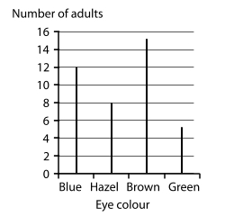 |  | Fill in the blanks of the frequency table below to match the information from the bar line chart:  Eye Colour Tally Marks Frequency  Blue  Hazel  Brown  Green  Total  How many adults were asked?  2 more adults with blue eyes were added to the data,  Would the most popular eye colour change?
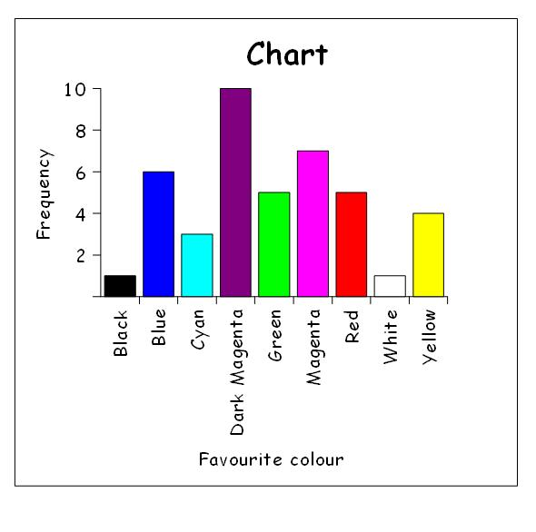 |  | Chloe has created a bar chart using the information in the frequency table below:  Favourite Colour Tally Marks Frequency  Black I 1  Blue IIII I 6  Cyan III 2  Dark Magenta IIII IIII 10  Green IIII 5  Magenta IIII II 7  Red IIII 6  White I 1  Yellow IIII 4  Total 42  Has she made any mistakes?  (Circle any mistakes and write the correction).
 |  | Extension Questions
Which number was thrown most often?

How many times was the dice thrown?

If you get a prize of 50p every time you throw a number greater than 4, how much money would you have after these throws?
True or False
Girls’ favourite subject is Maths.
More boys than girls chose science.
Maths is the most popular subject in the class.

How many girls are there?
How many students chose ‘other’?

