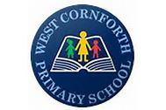
West Cornforth Primary School WB: 30.3.20 Weekly Overview of Home Learning - Year 1
Topic Whole School- Journeys
Monday | Maths- Measures- Weight  Starter- Use ‘Weekly Maths Starter Tasks’ PowerPoint. See resources on school website. Look at day 1. Check to reveal answers.  Main Activity- https://whiterosemaths.com/homelearning/year-1/ Use white rose home learning resources- Look at Year 1- Week 1 – Lesson 1. Introduction. Watch the video provided and discuss the key questions and learning points. Work with your child to answer the questions and pause the video as needed to give thinking and discussion time.  Following the completion of the video complete the independent task day 1. – See resources. | Literacy  Phonics- Phonics Play- Flash cards (Phase 3&5) Play buried treasure.  Literacy- Talk about different journeys we can take to different places. How can we get to these places? Begin to discuss transport. Discuss the fact that there are lots of different modes of transport. Talk about the fact that some move on water, land or sky. Can you name any modes of transport?  Look at the image at the top of the sheet (see resources for Monday.) Can the children write about the different modes of transport they can see? | Geography  Recap – What is special about our local area?  Use google earth (street view) to look at what we have in our local area on High Street. Look at where High  Street begins and ends. Focus on this area when talking about the features.  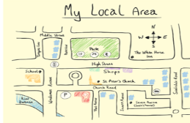  Can you draw your own simple map to show a certain part of our local area? Use google earth and google maps to help. Can you create your own key? Can you add some map symbols? Remind the children that we have already learnt about basic map symbols in class.
Tuesday | Maths  Starter- Use ‘Weekly Maths Starter Tasks’ PowerPoint. See resources on school website. Look at day 2. Check to reveal answers.  Main Activity- https://whiterosemaths.com/homelearning/year-1/  Use white rose home learning resources- Look at Year 1- Week 1 – Lesson 2. Measure mass. Watch the video provided and discuss the key questions and learning points. Work with your child to answer the questions and pause the video as needed to give thinking and discussion time.  Following the completion of the video complete the independent task day 2. – See resources | Literacy  Phonics- Phonics Play- Flash cards (Phase 3&5) Dragons Den.  Literacy- Can you design, draw and label and boat that you could use to travel to different places?  Children complete task- See resources for sheet.  Can you write about your mode of transport? Describe your design. Think about the inside and outside.  Begin to talk to the children about where they could travel to on their boat. | Art  Spring Art- Paint- Look at colours. Use brushes and finger printing.  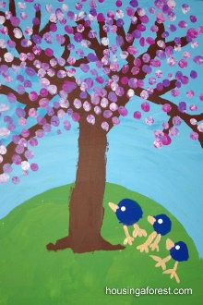 | PE  - https://www.youtube.com  /user/thebodycoach1. Join in with Joe Wicks daily PE session on his YouTube- The Body Coach.  - Go into your garden or own outdoor space and make an obstacle course to complete.
Wednesday | Maths  Starter- Use ‘Weekly Maths Starter Tasks’ PowerPoint. See resources on school website. Look at day 3. Check to reveal answers.  Main Activity- https://whiterosemaths.com/homelearning/year-1/  Use white rose home learning resources- Look at Year 1- Week 1 – Lesson 1. Compare mass. Watch the video provided and discuss the key questions and learning points. Work with your child to answer the questions and pause the video as needed to give thinking and discussion time.  Following the completion of the video complete the independent task day 3. – See resources | Literacy  Phonics- Flash cards (Phase 3&5) Phonics play- Tricky word trucks. Can you write sentences with these tricky words in?  Literacy- Encourage the children to imagine they can travel to their own island on their boat. What would the island look like? What would be on the island? Look at example images of fantasy islands- see resources.  Can you draw and label your own island design? Use template provided in resources. | Science  Can you sink the boat?  Tin foil normally floats but as we add more weight to it the downwards force becomes too much. Try different designs and see which works best.  Instructions:  https://www.fizzicseducation.com.au/150-science-experiments/force-movementexperiments/sink-the-foil-boat/  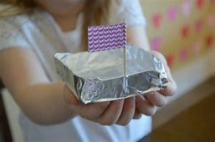  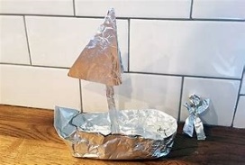
Thursday | Maths  Starter- Use ‘Weekly Maths Starter Tasks’ PowerPoint. See resources on school website. Look at day 4. Check to reveal answers.  Main Activity- Discuss the fact that we can measure weight using non-standard units such as cubes or pebbles and we can also measure weight using standard units. Link to our learning last week when we measured height in cm. Use this link to introduce the concept of measuring weight in g and kg. https://www.youtube.com/watch?v=ivAD44nh0D0  Watch the video provided and discuss the key questions and learning points.  Following the completion of the video complete the independent task day 4. – See resources. | Literacy  Phonics- Flash cards (Phase 3&5) Make a match. Write words- Whiteboards.  Literacy- Look back at the Fantasy island you designed yesterday. Imagine that you could open the island to the public, like a theme park. How much would be cost? How would people get there? Do you have food and drinks? Can they stay over?  Complete a leaflet to try and encourage people to visit your island. Look at the design. Why would people be interested in visiting your island. | Art/DT  Design and then make a boat from different junk you can find around your house. Look at google images for ideas.  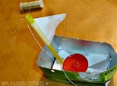  Science link- Does it float or sink? Which material is best? | PE  - https://www.youtube.com  /user/thebodycoach1. Join in with Joe Wicks daily PE session on his YouTube- The Body Coach.  - Go into your garden or own outdoor space and make an obstacle course to complete.
Friday | Maths  Starter- Use ‘Weekly Maths Starter Tasks’ PowerPoint. See resources on school website. Look at day 5. Check to reveal answers.  Main Activity-  Recap measuring weight in g and kg.  Complete some sort of simple cooking or baking task which involves the children measuring out ingredients using a simple set of scales. This could even be making a meal you would normally be making. You could write/make up a list of ingredients that need to be measured out, e.g. 100g of copped carrots or cheese. | Literacy  Phonics- Flash cards (Phase 3&5) Sentence level games- Phonics Play.  Literacy- Complete the leaflet that you started yesterday.  If you completed this, then try making a simple poster to encourage people to visit your fantasy island. Include: name, how to get there, special features, cost, food and drinks etc. Include a title, images and simple sentences. | History  Find out about how transport had changed over time.  Look at PowerPoint provided- see resources. Discuss key points and talk about images.  Complete independent task- see resources.
Useful Websites for Extra Tasks/Activities
Phonics  https://www.phonicsplay.co.uk/  Username – march20 Password – home  https://www.teachyourmonstertoread.com/games/tm1/demo  https://www.phonicsbloom.com/  https://www.topmarks.co.uk/english-gam…/…/letters-and-sounds | Maths  www.mathletics.com  www.ttrs.com  www.topmarks.co.uk  https://www.oxfordowl.co.uk/for-home/  https://www.bbc.co.uk/iplayer/episodes/b08bzfnh/numberblocks  www.whiterosemaths.com/homelearning/
English  https://www.topmarks.co.uk/…/7-11-years/spelling-and-grammar  www.sooperbooks.com  https://www.oxfordowl.co.uk/for-home/  www.spellingframe.co.uk  http://www.funenglishgames.com/games.html  https://www.eslgamesplus.com/  www.pobble365.com  www.readtheory.org  https://www.scholastic.com/…/scholastic-learn-at-home--free…# | Other  https://www.si.edu/kids - Fun lessons on geography, history and science  https://www.shaunsgameacademy.co.uk/ - Computing  https://scratch.mit.edu/ - Computing – click ‘create’  https://www.duolingo.com/register - Languages  https://mrnussbaum.com/science - Science  https://www.gonoodle.com/good-energy-at-home-kids-games-an…/ - Free exercise videos  https://www.virtualmusicalinstruments.com/ - Music

