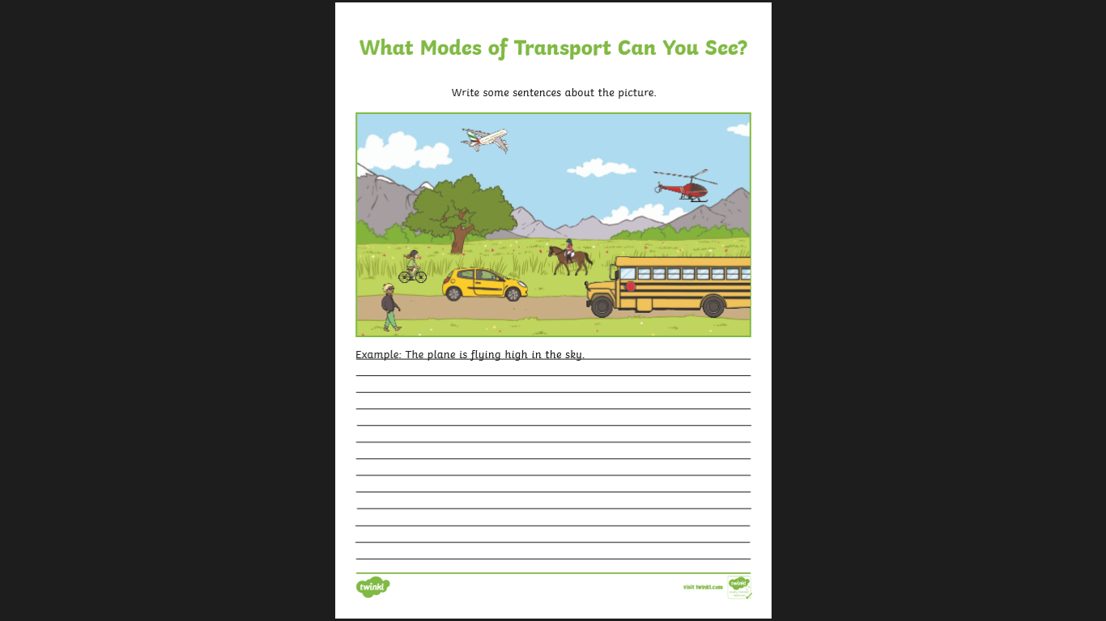

**Monday Task**

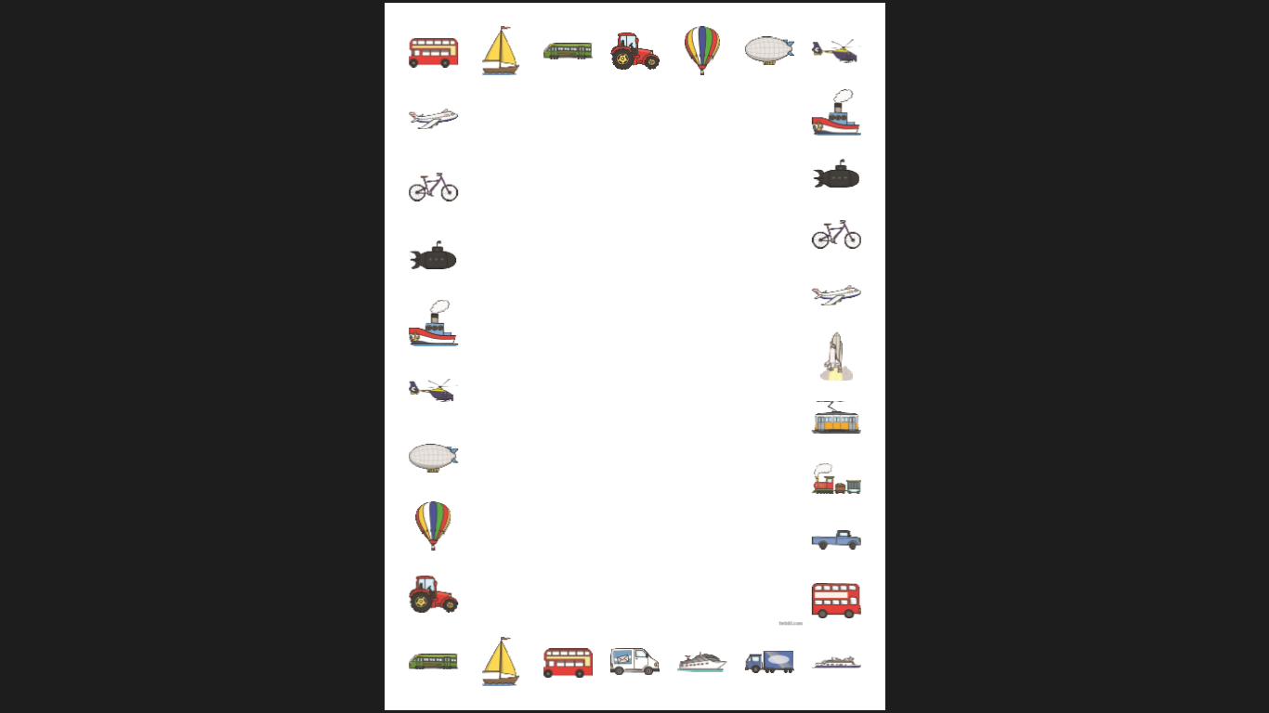

**Tuesday Task**

Can you design, draw and label and **boat** that you could use to travel to different places?

Can you write about your mode of transport? Describe your design. Think about the inside and outside.

______________________________________________________________________________________________________________________________________________________________________________________________________________________________________________________________________________________________________________________________________________________________________________________________________________________________________________________________________________________________________________________________________________________________________________________________________________________________________________________________________________________________________________

_________________________________________________________________________________________________________________________

_________________________________________________________________________________________________________________________

**Wednesday Task**

**Island Ideas**

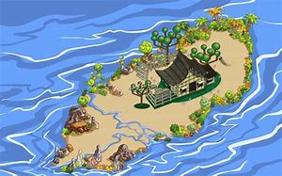

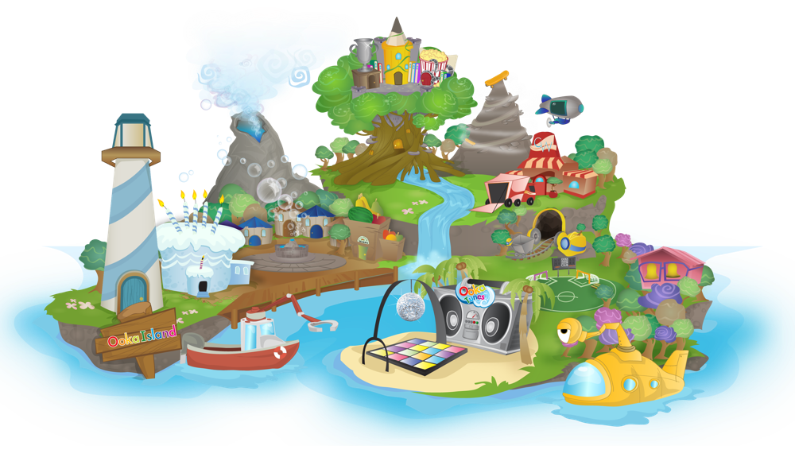

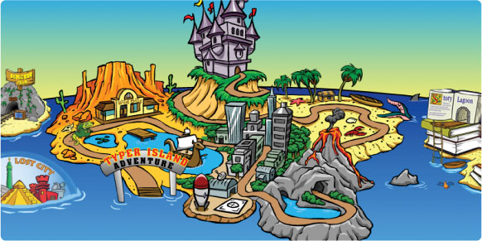

**Wednesday Task**

**Can you draw and label your own island design?**

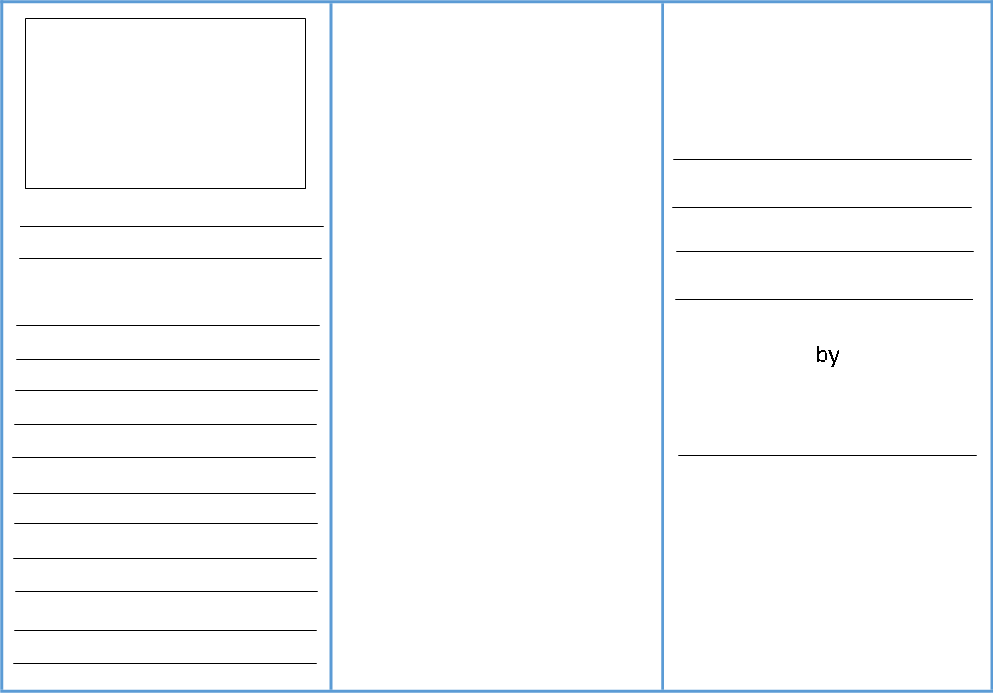

**Thursday Task**

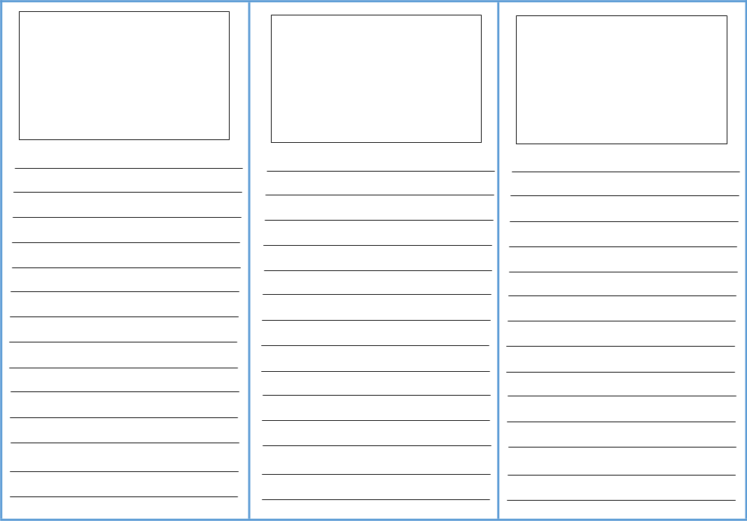

**Friday Task**