Drawing Bar Charts
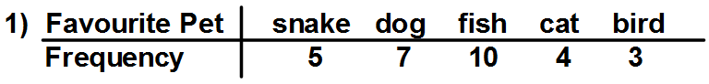
Complete the bar chart below.
People’s favourite Pets
 | snake |  |  |  | dog |  |  |  | fish |  |  |  | cat |  |  |  | bird
10
8
Frequency
6
4
0
2

Type of pet
2)

Draw the bar chart on the grid below.

