[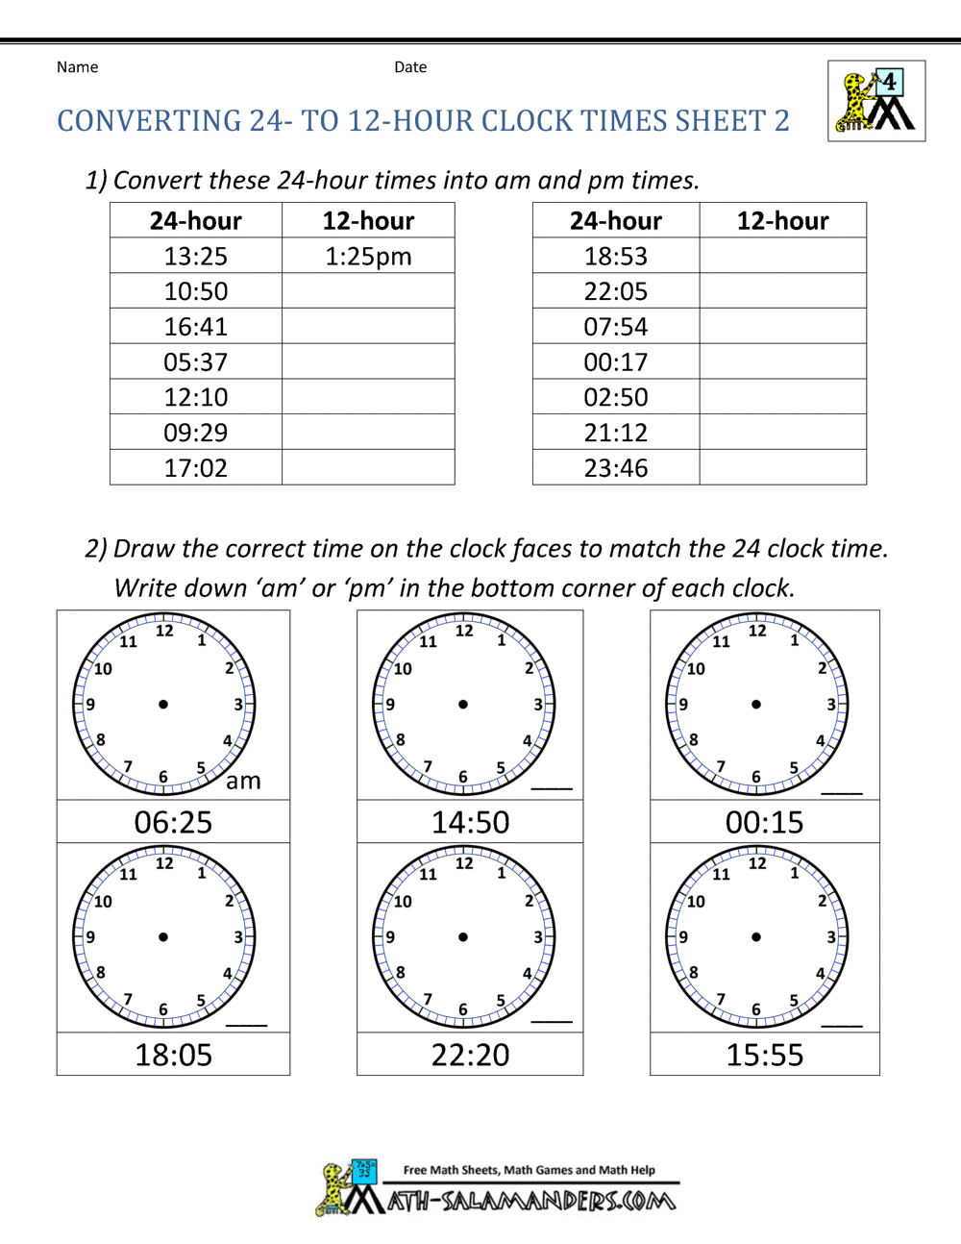](https://www.google.com/url?sa=i&url=https%3A%2F%2Fwww.math-salamanders.com%2F24-hour-clock-conversion.html&psig=AOvVaw1H3j4ThPlEWgdgIMmtTBBL&ust=1585306437805000&source=images&cd=vfe&ved=0CAIQjRxqFwoTCICi5-_8t-gCFQAAAAAdAAAAABAE)